Data Structures and Algorithm using Python

Lab Programs:

Program1

Recursion

Recursion is the process of defining something in terms of itself.

**Recursion Function:**

**Program 1:**

# Write Python Program to Perform Recursion operation to find factorial for given integers.

def factorial(x):

"This is a recursive function to find the factorial of an integer"

if x == 1:

return 1

else:

return (x * factorial(x-1))

num = 3

print("The factorial of", num, "is", factorial(num))

**Output:**

The factorial of 3 is 6

**Reference:**

factorial(3) #1st call with 3

3 * factorial(2) #2nd call with 2

3 * 2 * factorial(1) #3rd call with 1

3 * 2 *1 # return from 3rd call as number=1

3 * 2 #return from 2nd call

6 #return from 1st call

**Linear recursion:**

## 

Linear Search is a searching algorithm in which we sequentially search for a presence of a particular element inside a list or array.

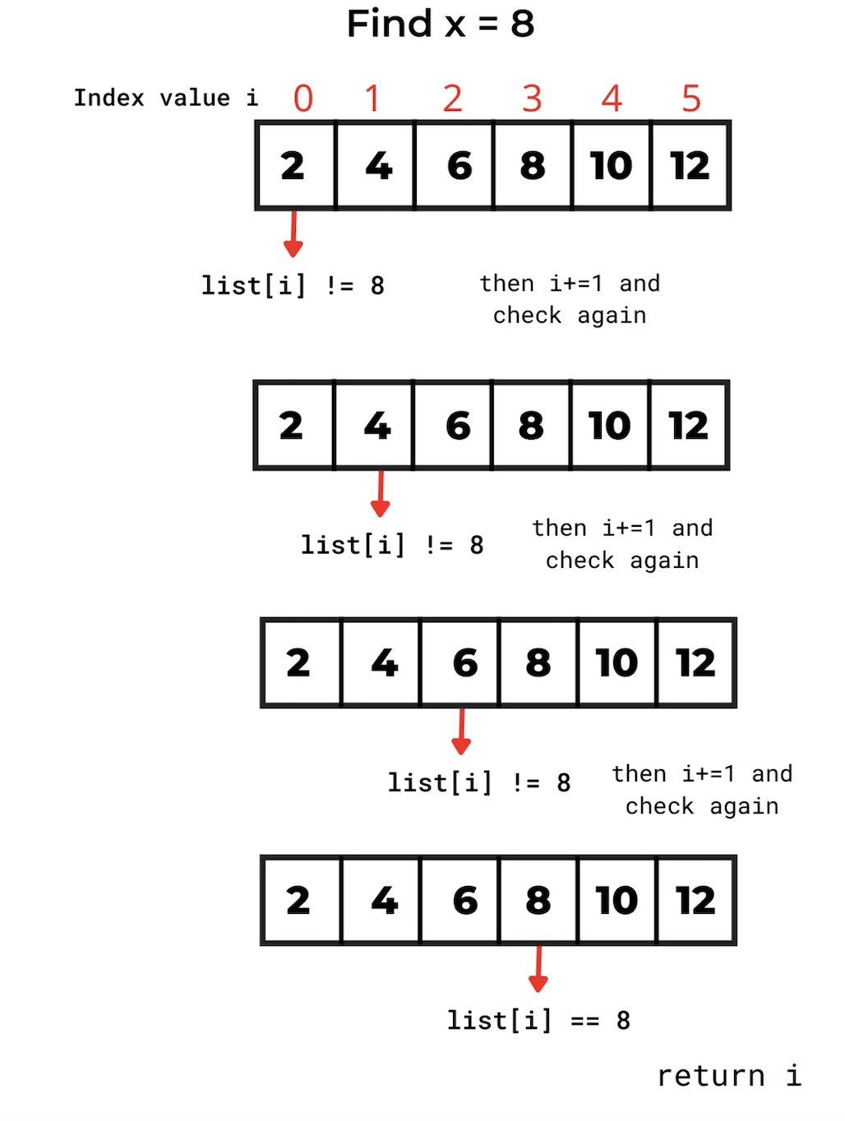

**Program 2:**

# Write Python Program to Perform Linear Search using Recursion to find the element is found or not and its position.

L1= [2,4,6,8,10,12]

x=8 # element that we want to be found

i=0 # pointer

while i<len(L1):

if L1[i]==x:

print(f'element {x} present at {i}th position')

break

i+=1

if i>=len(L1):

print('Element is not present')

**Output:**

Element 8 present at 3th position

--------------------------------------------------------------------------------

**Program 3:**

# Write Python Program to Perform Linear Search using Recursion to display the element in the array and find the element using its index.

def linear_search(L, key, i):

if i >= len(L):

return -1

if L[i] == key:

return i

return linear_search(L, key, i + 1)

L = [1, 2, 3, 4, 5, 6, 7]

key = 5

x = linear_search(L, key, 0)

if x != -1:

print('List : ', L)

print(f'Element {key} is available on index : {x}')

else:

print(‘The element is not present’)

**Output:**

List: [1,2,3,4,5,6,7]

Element 5 is available on index : 4

--------------------------------------------------------------------------------

**Binary Recursion:**

Given a sorted array of n integers and a target value, determine if the target exists in the array in logarithmic time using the binary search algorithm. If target exists in the array, print the index of it.

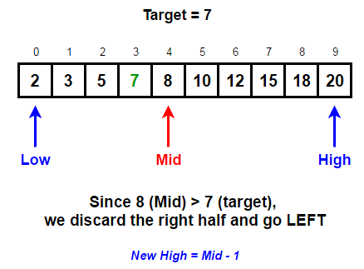

**Samples:**

Input: nums[] = [2, 3, 5, 7, 9]

target = 7

Output: Element found at index 3

Input: nums[] = [1, 4, 5, 8, 9]target = 2

Output: Element not found

**Program 4:**

# Write Python Program to Perform Binary Search using Recursion using a array to find the position of an element in an index.

# Returns index of x in arr if present, else -1

def binary_search(arr, low, high, x):

# Check base case

if high >= low:

mid = (high + low) // 2

# If element is present at the middle itself

if arr[mid] == x:

return mid

# If element is smaller than mid, then it can only

# be present in left subarray

elif arr[mid] > x:

return binary_search(arr, low, mid - 1, x)

# Else the element can only be present in right subarray

else:

return binary_search(arr, mid + 1, high, x)

else:

# Element is not present in the array

return -1

# Test array

arr = [ 2, 3, 4, 10, 40 ]

x = 10

# Function call

result = binary_search(arr, 0, len(arr)-1, x)

if result != -1:

print("Element is present at index", str(result))

else:

print("Element is not present in array")

Output:

Element is present at index 3

**Program 5:**

# Write Python Program to Perform Binary Search using Recursion to display the element in the array and find the element using its index.

# Write Python Program to Perform Binary Search using Recursion

def binary_search(L, key, low, high):

if high >= low:

mid = (low + high) // 2

if key == L[mid]:

return mid

elif key > L[mid]:

return binary_search(L, key, mid + 1, high)

else:

return binary_search(L, key, low, mid - 1)

else:

return -1

L = [11, 22, 33, 44, 55, 66, 77]

key = 44

idx = binary_search(L, key, 0, len(L) - 1)

if idx!=-1:

print(f'In list {L} the key {key} lies on index : {idx} ')

else:

print(‘The element is not present in array’)

**Output:**

In list [11,22,33,44,55,66,77] the key 44 lies on index : 3

**Stack Data Structure**

A stack is a linear data structure that follows the principle of **Last In First Out (LIFO)**. This means the last element inserted inside the stack is removed first.

You can think of the stack data structure as the pile of plates on top of another.

## LIFO Principle of Stack

In programming terms, putting an item on top of the stack is called **push** and removing an item is called **pop**.

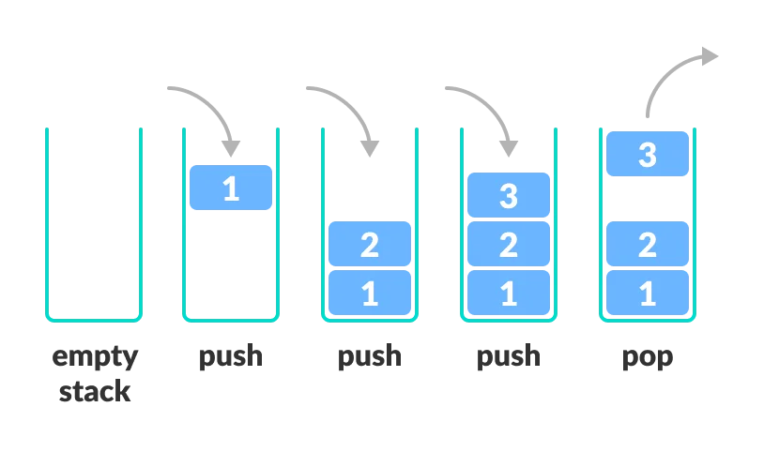

## Basic Operations of Stack

There are some basic operations that allow us to perform different actions on a stack.

* **empty()** – Returns whether the stack is empty – Time Complexity: O(1)
* **size()** – Returns the size of the stack – Time Complexity: O(1)
* **top() / peek()**– Returns a reference to the topmost element of the stack – Time Complexity: O(1)
* **push(a)** – Inserts the element ‘a’ at the top of the stack – Time Complexity: O(1)
* **pop()** – Deletes the topmost element of the stack – Time Complexity: O(1)

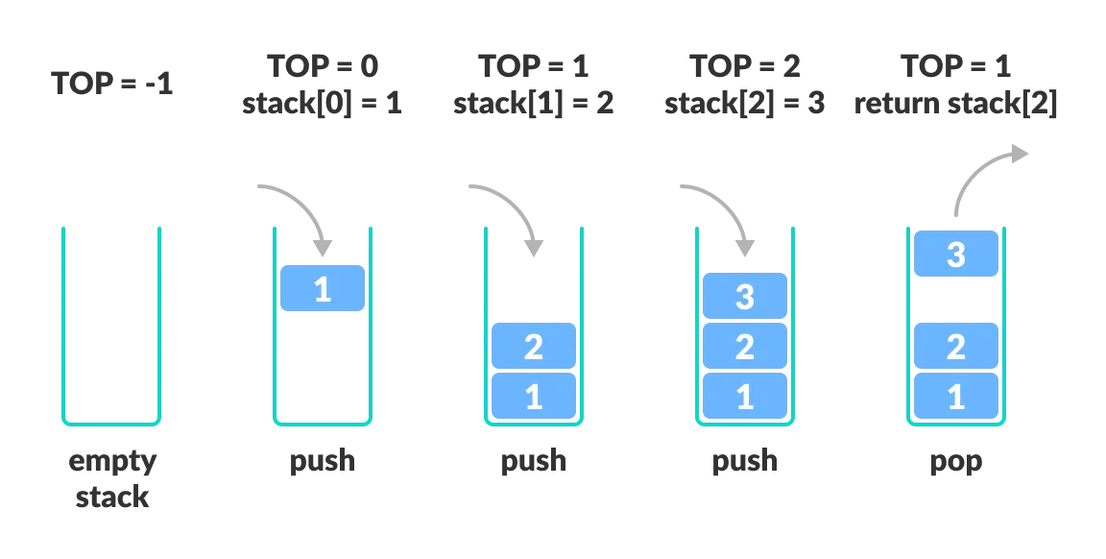

**Program 6:**

# Write Python Program to Perform Stack operation to print in reverse sort.

# Python program to

# demonstrate stack implementation

# using list

stack = []

# append() function to push

# element in the stack

stack.append('a')

stack.append('b')

stack.append('c')

print('Initial stack')

print(stack)

# pop() function to pop

# element from stack in

# LIFO order

print('\nElements popped from stack:')

print(stack.pop())

print(stack.pop())

print(stack.pop())

print('\nStack after elements are popped:')

print(stack)

# uncommenting print(stack.pop())

# will cause an IndexError

# as the stack is now empty

**Output**

Initial stack

['a', 'b', 'c']

Elements popped from stack:

c

b

a

Stack after elements are popped:

[]

**Program 7:**

# Write Python Program to Perform Stack pop operation to print the values in reverse order.

# Python program to

# demonstrate stack implementation

# using collections.deque

from collections import deque

stack = deque()

# append() function to push

# element in the stack

stack.append('a')

stack.append('b')

stack.append('c')

print('Initial stack:')

print(stack)

# pop() function to pop

# element from stack in

# LIFO order

print('\nElements popped from stack:')

print(stack.pop())

print(stack.pop())

print(stack.pop())

print('\nStack after elements are popped:')

print(stack)

# uncommenting print(stack.pop())

# will cause an IndexError

# as the stack is now empty

**Output**

Initial stack:

deque(['a', 'b', 'c'])

Elements popped from stack:

c

b

a

Stack after elements are popped:

deque([])

**Queue Data Structure**

A queue is a useful data structure in programming. It is similar to the ticket queue outside a cinema hall, where the first person entering the queue is the first person who gets the ticket.

Queue follows the **First In First Out (FIFO)** rule - the item that goes in first is the item that comes out first.

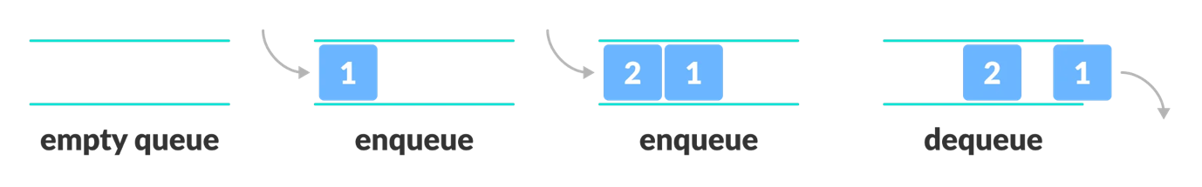

## Basic Operations of Queue

A queue is an object (an abstract data structure - ADT) that allows the following operations:

* **Enqueue**: Add an element to the end of the queue
* **Dequeue**: Remove an element from the front of the queue
* **IsEmpty**: Check if the queue is empty
* **IsFull**: Check if the queue is full
* **Peek**: Get the value of the front of the queue without removing it

## Working of Queue

Queue operations work as follows:

* two pointers FRONT and REAR
* FRONT track the first element of the queue
* REAR track the last element of the queue
* initially, set value of FRONT and REAR to -1

### Enqueue Operation

* check if the queue is full
* for the first element, set the value of FRONT to 0
* increase the REAR index by 1
* add the new element in the position pointed to by REAR

### Dequeue Operation

* check if the queue is empty
* return the value pointed by FRONT
* increase the FRONT index by 1
* for the last element, reset the values of FRONT and REAR to -1

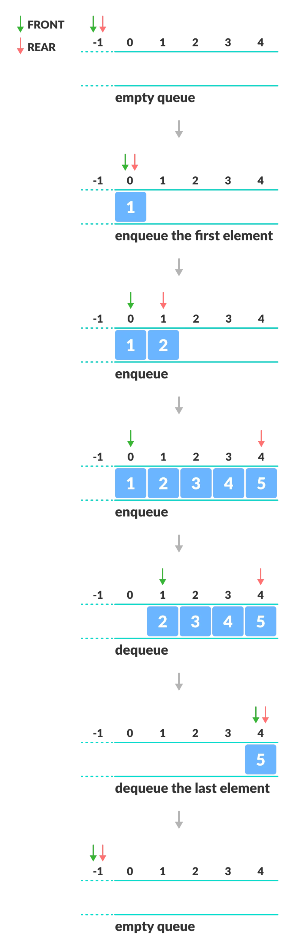

**Program 8:**

# Write Python Program to Perform Queue operation to do insert and remove method.

queue = []

queue.append('a')

queue.append('b')

queue.append('c')

print("Initial queue")

print(queue)

print("\nElements dequeued from queue")

print(queue.pop(0))

print(queue.pop(0))

print(queue.pop(0))

print("\nQueue after removing elements")

print(queue)

**Output:**

Initial queue  
['a', 'b', 'c']  
Elements dequeued from queue  
a  
b  
c  
Queue after removing elements  
[]

**Program 9**

from collections import deque

q = deque()

q.append('a')

q.append('b')

q.append('c')

print("Initial queue")

print(q)

print("\nElements dequeued from the queue")

print(q.popleft())

print(q.popleft())

print(q.popleft())

print("\nQueue after removing elements")

print(q)

**Output:** 

Initial queue  
deque(['a', 'b', 'c'])  
Elements dequeued from the queue  
a  
b  
c  
Queue after removing elements  
deque([])

**Program 10:**

# Write Python Program to Perform Queue operation to check the queue is empty and print the elements.

from queue import Queue

q = Queue(maxsize = 3)

print(q.qsize())

q.put('a')

q.put('b')

q.put('c')

print("\nFull: ", q.full())

print("\nElements dequeued from the queue")

print(q.get())

print(q.get())

print(q.get())

print("\nEmpty: ", q.empty())

q.put(1)

print("\nEmpty: ", q.empty())

print("Full: ", q.full())

**Output:** 

0  
Full: True  
Elements dequeued from the queue  
a  
b  
c  
Empty: True  
Empty: False  
Full: False

Linked List in Python

## What is Linked List in Python

A linked list is a type of linear data structure similar to arrays. It is a collection of nodes that are linked with each other. A node contains two things first is data and second is a link that connects it with another node. Below is an example of a linked list with four nodes and each node contains character data and a link to another node. Our first node is where **head** points and we can access all the elements of the linked list using the **head.**

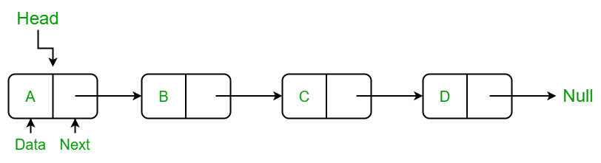

## **Creating a linked list in Python**

In this LinkedList class, we will use the Node class to create a linked list. In this class, we have an

**__init__**method that initializes the linked list with an empty head. **insertAtBegin()** method to insert a node at the beginning of the linked list.

**insertAtIndex()** method to insert a node at the given index of the linked list. **insertAtEnd()** method inserts a node at the end of the linked list. **remove_node()**method takes the data as an argument to delete that node.

**sizeOfLL()**method to get the current size of the linked list.

**printLL()** which traverses the linked list and prints the data of each node.

## **Insertion in Linked List**

### Insertion at Beginning in Linked List

### Insert a Node at a Specific Position in a Linked List

### Insertion in Linked List at End

### Update the Node of a Linked List

## **Delete Node in a Linked List**

### Remove First Node from Linked List

### Remove Last Node from Linked List

### Delete a Linked List Node at a given Position

### Delete a Linked List Node of a given Data

### **Linked List Traversal**

### **Length of a Linked List**

**Program 11:**

# Using Python write a Linked List Program to create a node class to create a node using different operations and print the elements.

# Create a Node class to create a node

class Node:

def __init__(self, data):

self.data = data

self.next = None

# Create a LinkedList class

class LinkedList:

def __init__(self):

self.head = None

# Method to add a node at begin of LL

def insertAtBegin(self, data):

new_node = Node(data)

if self.head is None:

self.head = new_node

return

else:

new_node.next = self.head

self.head = new_node

# Method to add a node at any index

# Indexing starts from 0.

def insertAtIndex(self, data, index):

new_node = Node(data)

current_node = self.head

position = 0

if position == index:

self.insertAtBegin(data)

else:

while(current_node != None and position+1 != index):

position = position+1

current_node = current_node.next

if current_node != None:

new_node.next = current_node.next

current_node.next = new_node

else:

print("Index not present")

# Method to add a node at the end of LL

def insertAtEnd(self, data):

new_node = Node(data)

if self.head is None:

self.head = new_node

return

current_node = self.head

while(current_node.next):

current_node = current_node.next

current_node.next = new_node

# Update node of a linked list

# at given position

def updateNode(self, val, index):

current_node = self.head

position = 0

if position == index:

current_node.data = val

else:

while(current_node != None and position != index):

position = position+1

current_node = current_node.next

if current_node != None:

current_node.data = val

else:

print("Index not present")

# Method to remove first node of linked list

def remove_first_node(self):

if(self.head == None):

return

self.head = self.head.next

# Method to remove last node of linked list

def remove_last_node(self):

if self.head is None:

return

current_node = self.head

while(current_node.next.next):

current_node = current_node.next

current_node.next = None

# Method to remove at given index

def remove_at_index(self, index):

if self.head == None:

return

current_node = self.head

position = 0

if position == index:

self.remove_first_node()

else:

while(current_node != None and position+1 != index):

position = position+1

current_node = current_node.next

if current_node != None:

current_node.next = current_node.next.next

else:

print("Index not present")

# Method to remove a node from linked list

def remove_node(self, data):

current_node = self.head

if current_node.data == data:

self.remove_first_node()

return

while(current_node != None and current_node.next.data != data):

current_node = current_node.next

if current_node == None:

return

else:

current_node.next = current_node.next.next

# Print the size of linked list

def sizeOfLL(self):

size = 0

if(self.head):

current_node = self.head

while(current_node):

size = size+1

current_node = current_node.next

return size

else:

return 0

# print method for the linked list

def printLL(self):

current_node = self.head

while(current_node):

print(current_node.data)

current_node = current_node.next

# create a new linked list

llist = LinkedList()

# add nodes to the linked list

llist.insertAtEnd('a')

llist.insertAtEnd('b')

llist.insertAtBegin('c')

llist.insertAtEnd('d')

llist.insertAtIndex('g', 2)

# print the linked list

print("Node Data")

llist.printLL()

# remove a nodes from the linked list

print("\nRemove First Node")

llist.remove_first_node()

print("Remove Last Node")

llist.remove_last_node()

print("Remove Node at Index 1")

llist.remove_at_index(1)

# print the linked list again

print("\nLinked list after removing a node:")

llist.printLL()

print("\nUpdate node Value")

llist.updateNode('z', 0)

llist.printLL()

print("\nSize of linked list :", end=" ")

print(llist.sizeOfLL())

**OUTPUT:**

Node Data

c

a

g

b

d

Remove First Node

Remove Last Node

Remove Node at Index 1

Linked list after removing a node:

a

b

Update node Value

z

b

Size of linked list : 2

**Program 12:**

# Using Python write a Double Linked List Program to perform Insert, Delete operation and print the elements.

# Initialise the Node

**class** **Node**:

**def** **__init__**(self, data):

       self.item = data

       self.next = None

       self.prev = None

# Class for doubly Linked List

**class** **doublyLinkedList**:

**def** **__init__**(self):

       self.start_node = None

   # Insert Element to Empty list

**def** **InsertToEmptyList**(self, data):

**if** self.start_node **is** None:

           new_node = Node(data)

           self.start_node = new_node

**else**:

**print**("The list is empty")

   # Insert element at the end

**def** **InsertToEnd**(self, data):

       # Check if the list is empty

**if** self.start_node **is** None:

           new_node = Node(data)

           self.start_node = new_node

**return**

       n = self.start_node

       # Iterate till the next reaches NULL

**while** n.next **is** **not** None:

           n = n.next

       new_node = Node(data)

       n.next = new_node

       new_node.prev = n

   # Delete the elements from the start

**def** **DeleteAtStart**(self):

**if** self.start_node **is** None:

**print**("The Linked list is empty, no element to delete")

**return**

**if** self.start_node.next **is** None:

           self.start_node = None

**return**

       self.start_node = self.start_node.next

       self.start_prev = None;

   # Delete the elements from the end

**def** **delete_at_end**(self):

       # Check if the List is empty

**if** self.start_node **is** None:

**print**("The Linked list is empty, no element to delete")

**return**

**if** self.start_node.next **is** None:

           self.start_node = None

**return**

       n = self.start_node

**while** n.next **is** **not** None:

           n = n.next

       n.prev.next = None

   # Traversing and Displaying each element of the list

**def** **Display**(self):

**if** self.start_node **is** None:

**print**("The list is empty")

**return**

**else**:

           n = self.start_node

**while** n **is** **not** None:

**print**("Element is: ", n.item)

               n = n.next

**print**("**\n**")

# Create a new Doubly Linked List

NewDoublyLinkedList = doublyLinkedList()

# Insert the element to empty list

NewDoublyLinkedList.InsertToEmptyList(**10**)

# Insert the element at the end

NewDoublyLinkedList.InsertToEnd(**20**)

NewDoublyLinkedList.InsertToEnd(**30**)

NewDoublyLinkedList.InsertToEnd(**40**)

NewDoublyLinkedList.InsertToEnd(**50**)

NewDoublyLinkedList.InsertToEnd(**60**)

# Display Data

NewDoublyLinkedList.Display()

# Delete elements from start

NewDoublyLinkedList.DeleteAtStart()

# Delete elements from end

NewDoublyLinkedList.DeleteAtStart()

# Display Data

NewDoublyLinkedList.Display()

**HEAPS USING PRIORITY QUEUE**

Abstract data structures specify operations and the relationships between them. The priority queue abstract data structure, for example, supports three operations:

1. **is_empty** checks whether the queue is empty.
2. **add_element** adds an element to the queue.
3. **pop_element** pops the element with the highest priority.

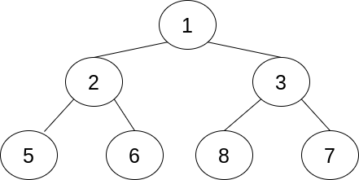

There are three rules that determine the relationship between the element at the index kand its surrounding elements:

1. Its first child is at 2*k + 1.
2. Its second child is at 2*k + 2.
3. Its parent is at (k - 1) // 2.

**Program 13:**

# Using Python write a Heaps Program to insert the element in a node, Sort, and print the elements.

# import modules

import heapq as hq

# list of students

list_stu = [(5,'Rina'),(1,'Anish'),(3,'Moana'),(2,'cathy'),(4,'Lucy')]

# Arrange based on the roll number

hq.heapify(list_stu)

print("The order of presentation is :")

for i in list_stu:

print(i[0],':',i[1])

Output:

The order of presentation is :

1 : Anish

2 : cathy

3 : Moana

5 : Rina

4 : Lucy

**Program 14:**

# Using Python write a Heaps Program to perform Insert, Swap,Delete, and print the elements.

**# Priority Queue implementation in Python**

**# Function to heapify the tree**

def heapify(arr, n, i):

**# Find the largest among root, left child and right child**

largest = i

l = 2 * i + 1

r = 2 * i + 2

**if** l < n and arr[i] < arr[l]:

largest = l

**if** r < n and arr[largest] < arr[r]:

largest = r

**# Swap and continue heapifying if root is not largest**

**if** largest != i:

arr[i], arr[largest] = arr[largest], arr[i]

heapify(arr, n, largest)

**# Function to insert an element into the tree**

def insert(array, newNum):

size = len(array)

**if** size == 0:

array.append(newNum)

**else**:

array.append(newNum)

**for** i in range((size // 2) - 1, -1, -1):

heapify(array, size, i)

**# Function to delete an element from the tree**

def deleteNode(array, num):

size = len(array)

i = 0

**for** i in range(0, size):

**if** num == array[i]:

**break**

array[i], array[size - 1] = array[size - 1], array[i]

array.remove(size - 1)

**for** i in range((len(array) // 2) - 1, -1, -1):

heapify(array, len(array), i)

arr = []

insert(arr, 3)

insert(arr, 4)

insert(arr, 9)

insert(arr, 5)

insert(arr, 2)

print ("Max-Heap array: " + str(arr))

deleteNode(arr, 4)

print("After deleting an element: " + str(arr))

Output: